KENDRIYA VIDYALAY, MOHALI
NIPUN NEWS LETTER 2023-24
Education is not the learning of facts, but the training of the mind to think, Albert Einstein.

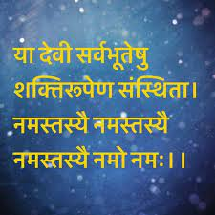
-----------MESSAGE---------
It is a matter of great delight that Kendriya Vidyalaya Mohali is going to publish its News Letter of the Session 2023-24 as a part of the NIPUN for qualitative improvement of Primary Education. (Term-l)
The News Letter reflects the creativity, innovation, reasoning power and skill which are being developed in the students.
The empowerment of primary education requires sincere efforts and devotion and NIPUN is capable of generating motivation in the primary students to accept the challenges.
I feel privileged to have such a hardworking staff and enthusiastic students who work day in, day out in their pursuit of excellence.

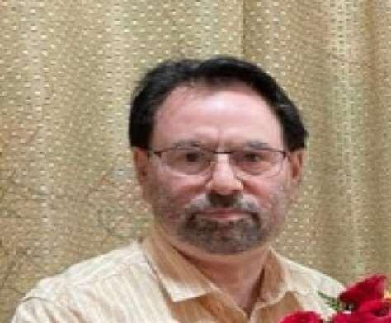
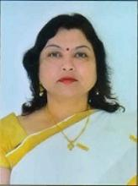
MRS. PREETI SAXENA (DC) MR. JUGAL KISHORE (AC)
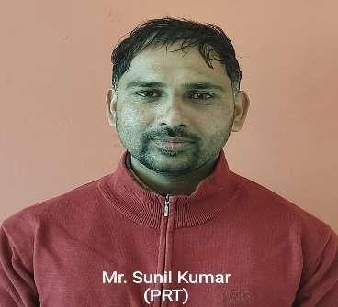
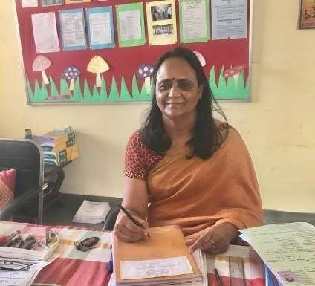
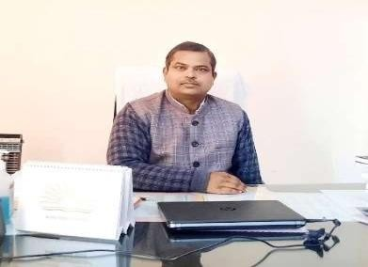

EDOTOR IN CHIEF EDITOR EDITOR AND DESIGNER
MR. JAGESHWAR (PRINCIPAL) MRS.ALKA GOHIL (HM) SUNILKUMAR (PRT)

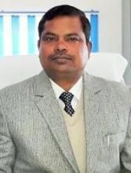
MESSAGE BY THE PRINCIPAL
Dear Students,
Success is a word which sounds very good but it requires hard work to achieve. Everybody wants to achieve success in life but very few people among them work in the right direction and get success. If we try with strong will- power, faith and determination, nothing is impossible.When a person works hard to get success, he gets the fruits of his patience, but many a time success does not come immediately. But we should not loose heart because failure is the first step to success. According to M.K. Gandhi “If you have faith in the cause and means and in God, the hot sun will be cool for you.” So Faith plays a very important role in everybody’s life, it is said that he who loses money loses much; he who loses a friend, loses more; but he who loses faith loses all’.
When we look at the lives of most outstanding personalities of the world, we find that it was faith which made their life exemplary. Students! When a person does hard work to reach his goal, he should only concentrate on his work leaving the thought whether he will get through or not. We should not leave anything to destiny because our hard work and sincere efforts towards achieving success matter a lot.
So my dear students! It is up to you to make life a success by realizing the strength within yourself and I am always with you in each and every step but only you will have to walk on the path.
BALVATIKA
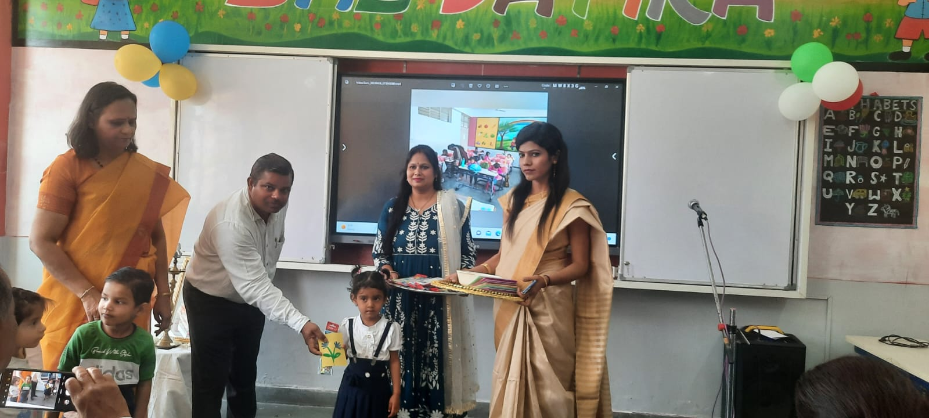
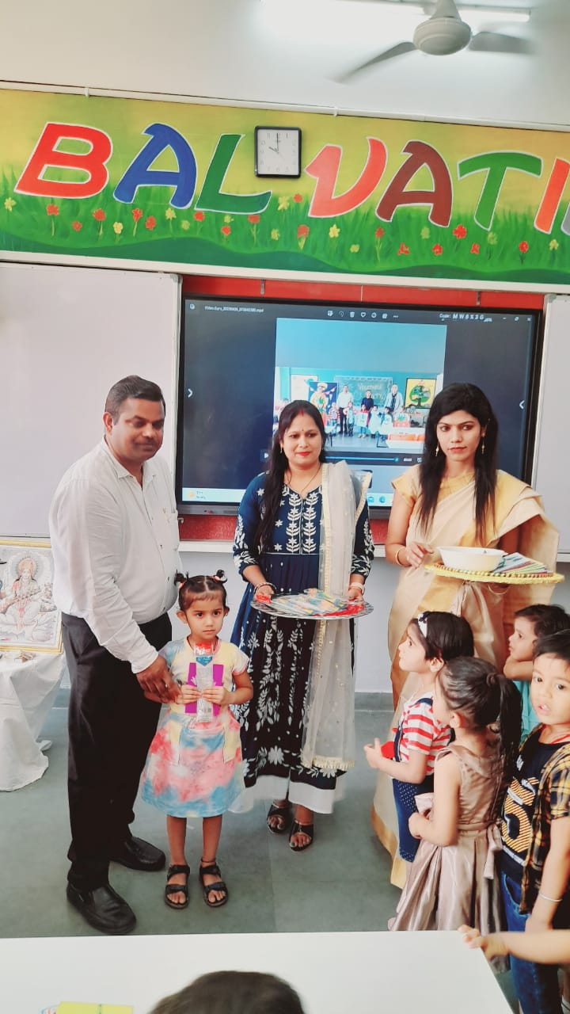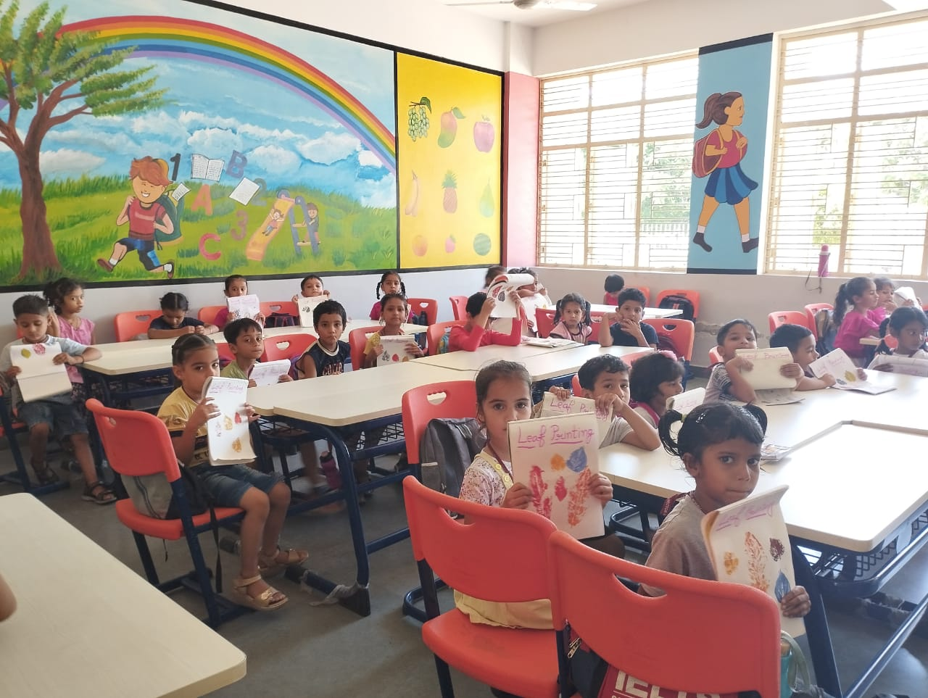
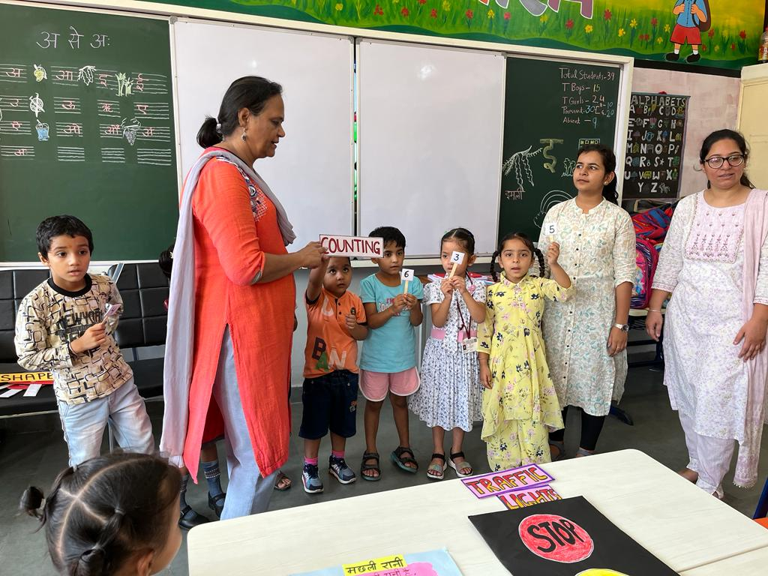
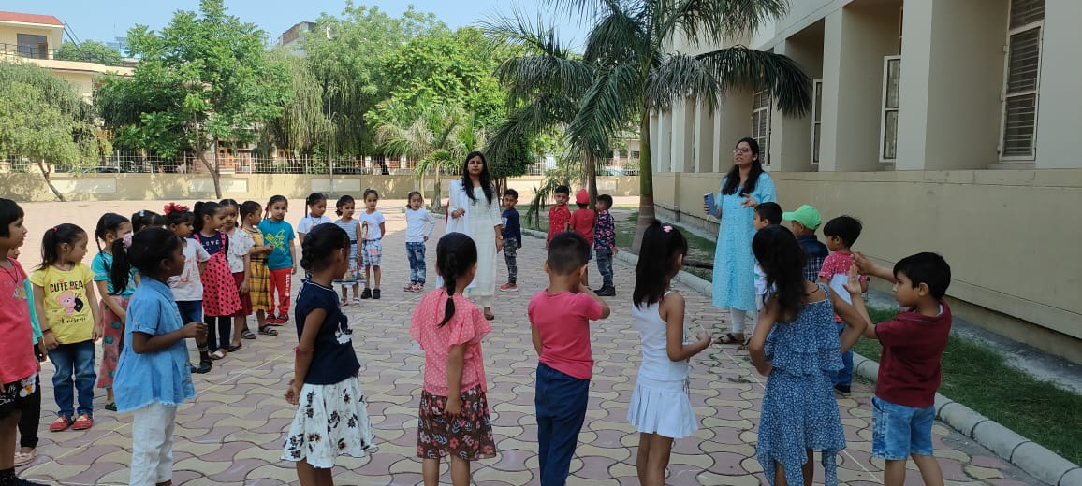
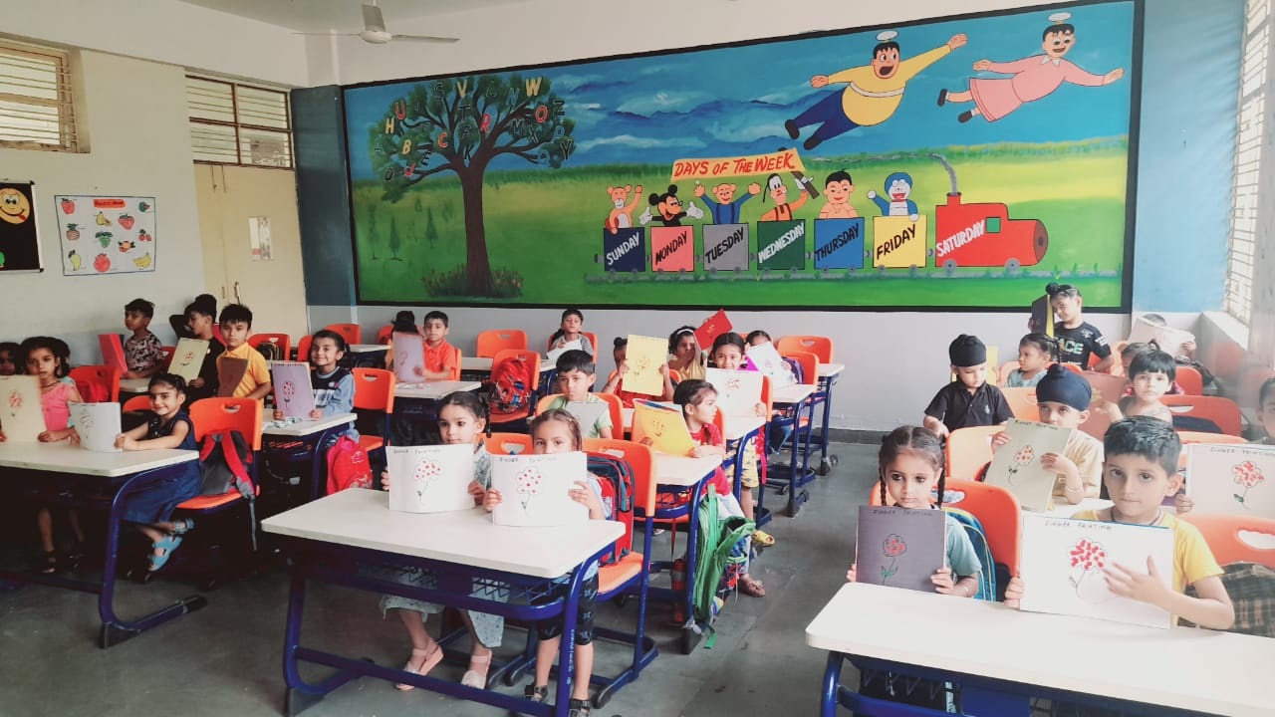
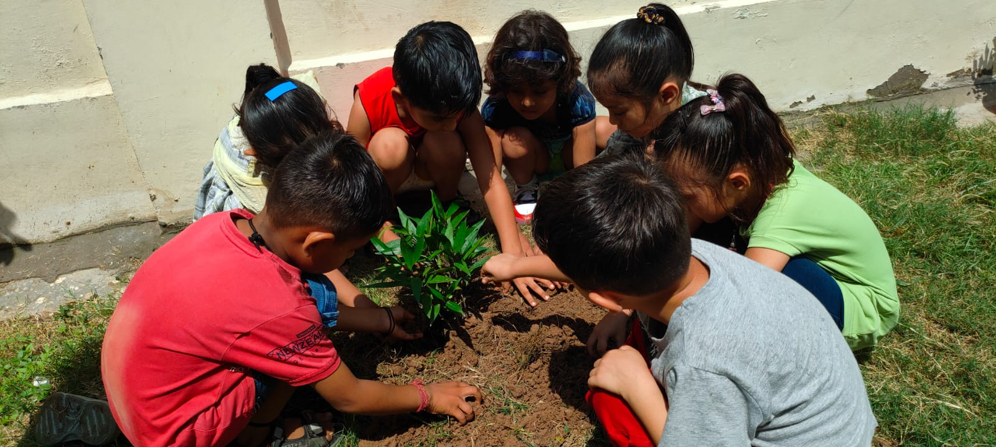
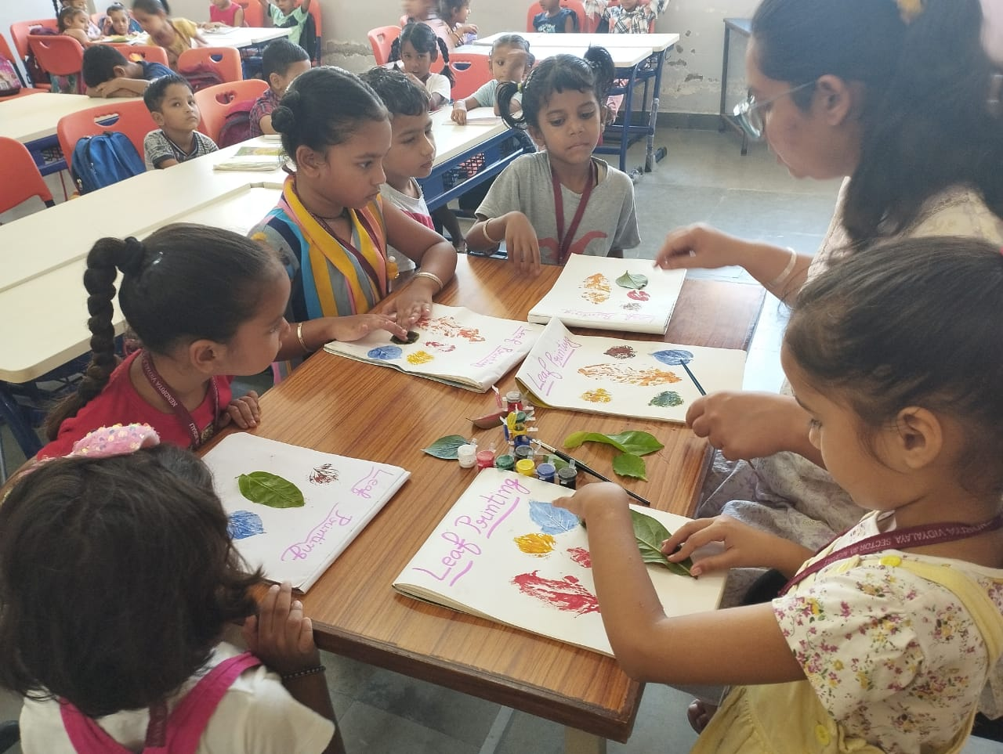
WELCOME OF CLASS -1
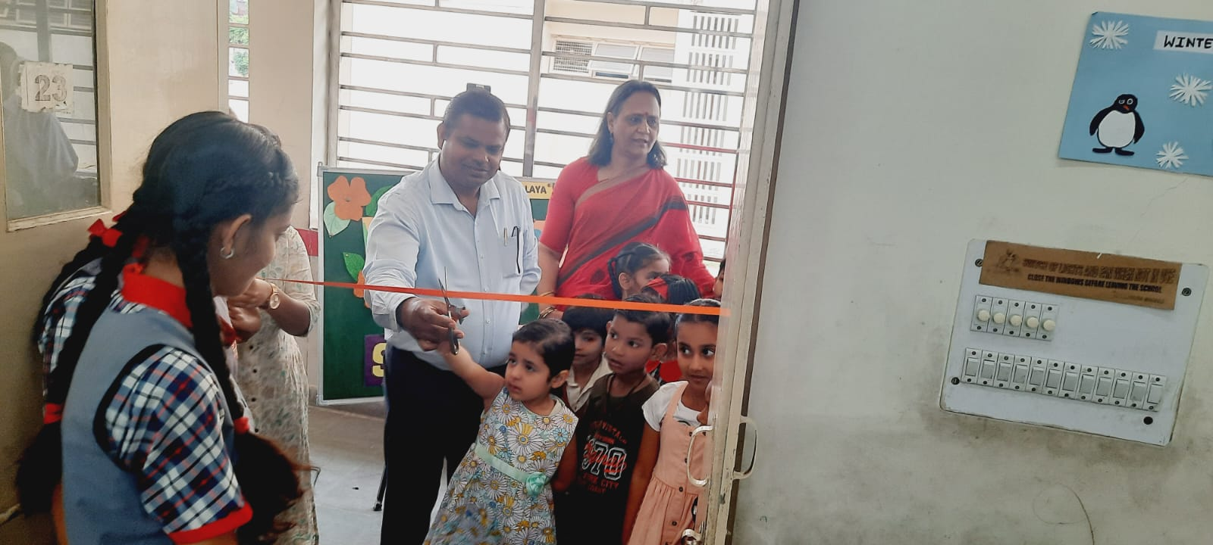
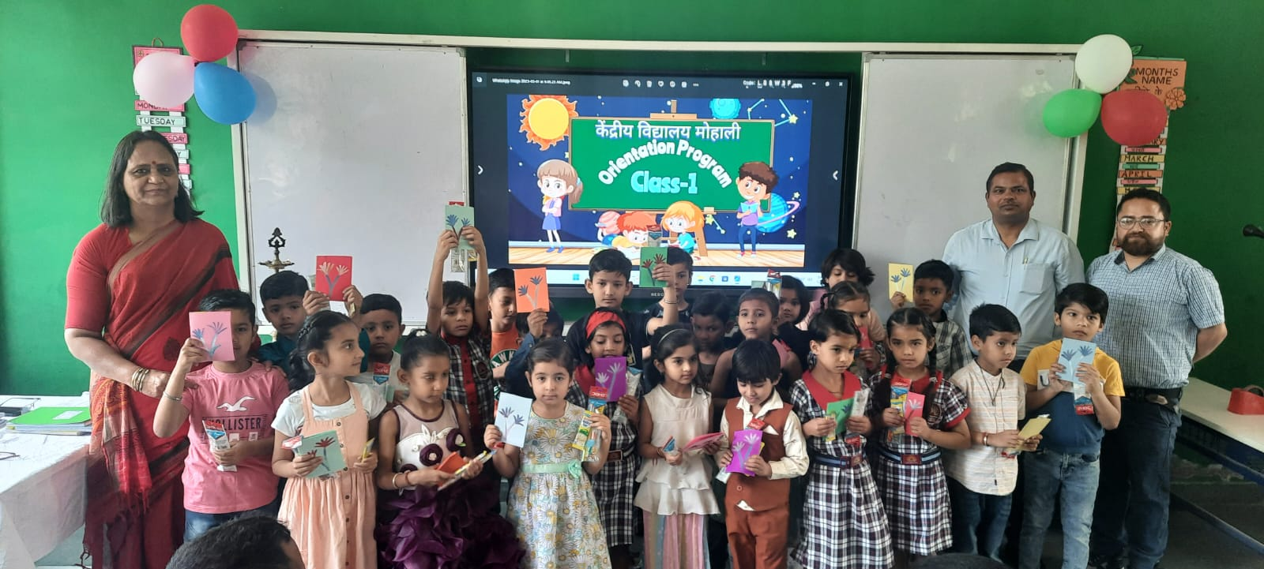
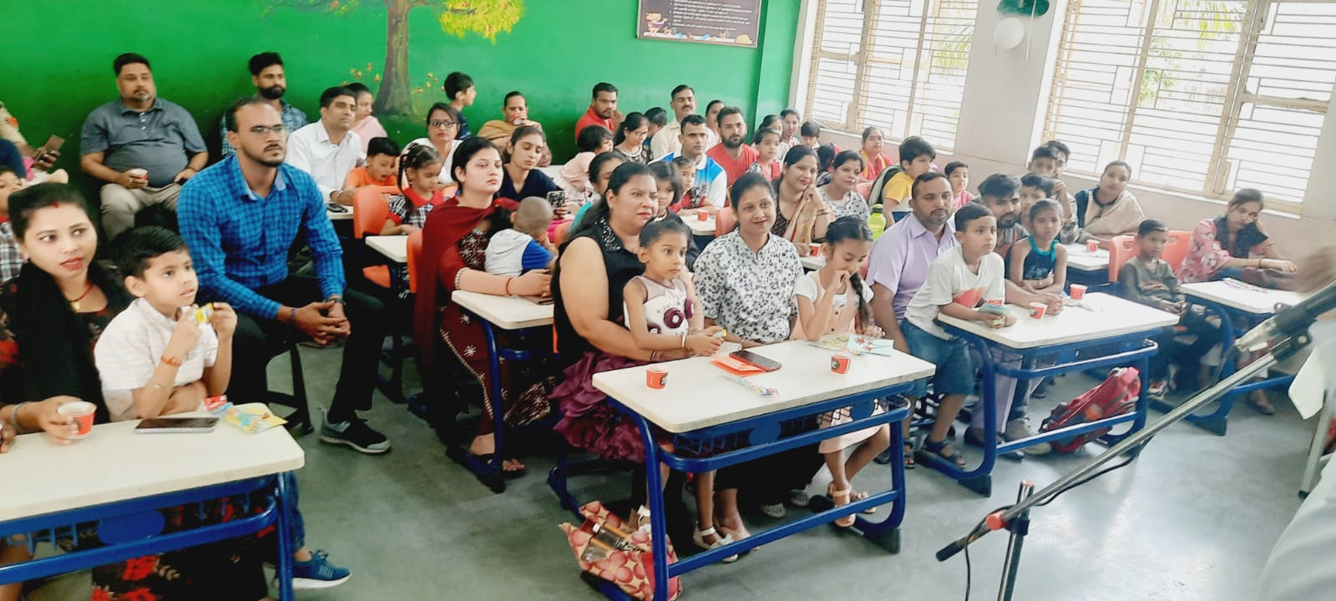
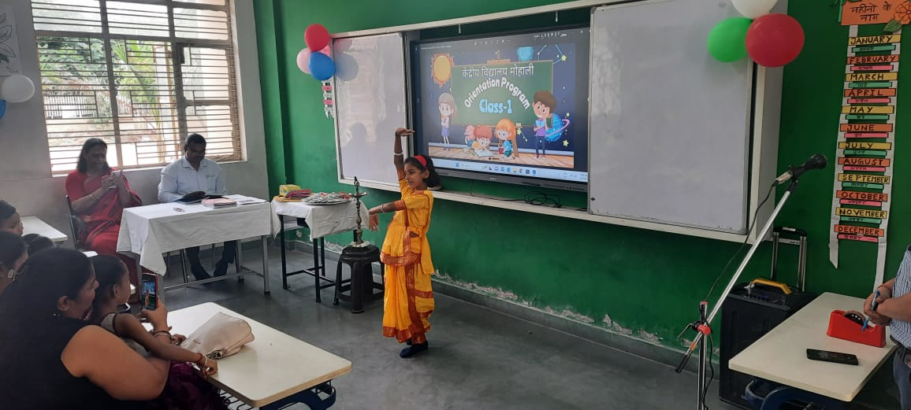
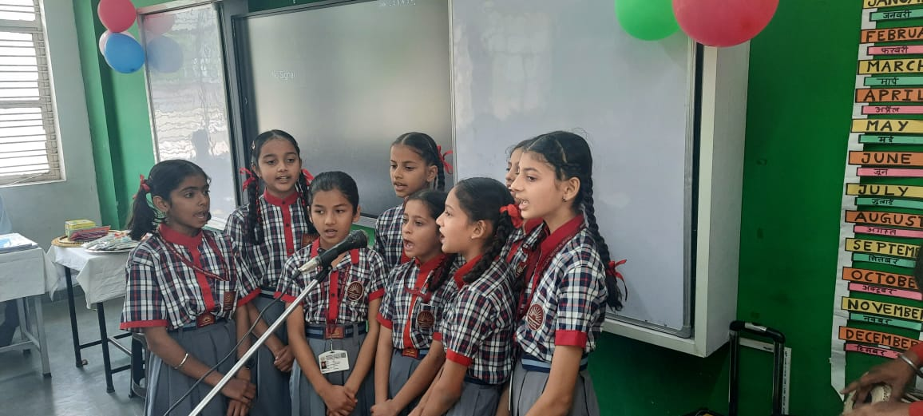
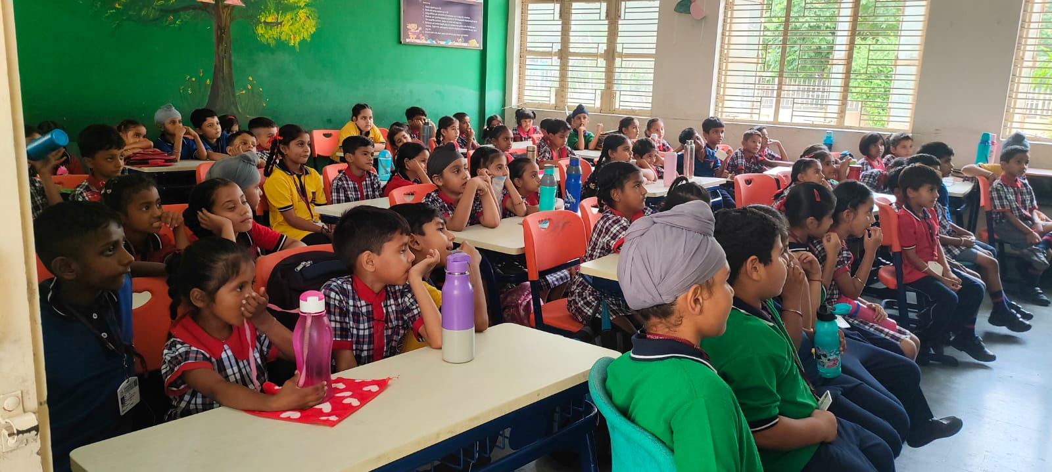
CCA
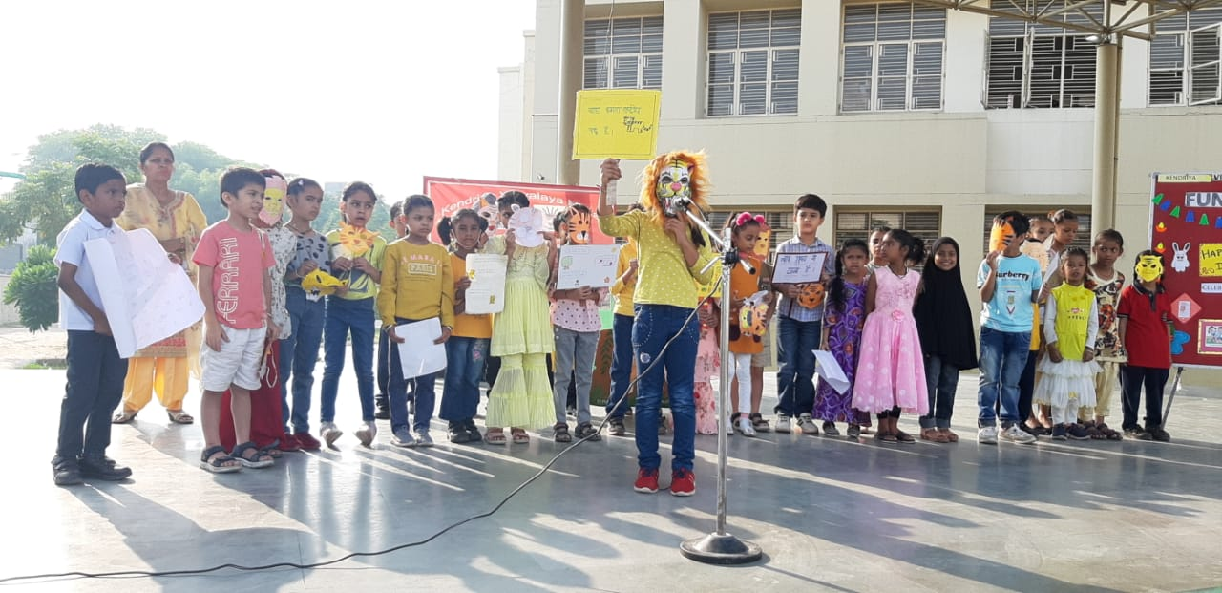
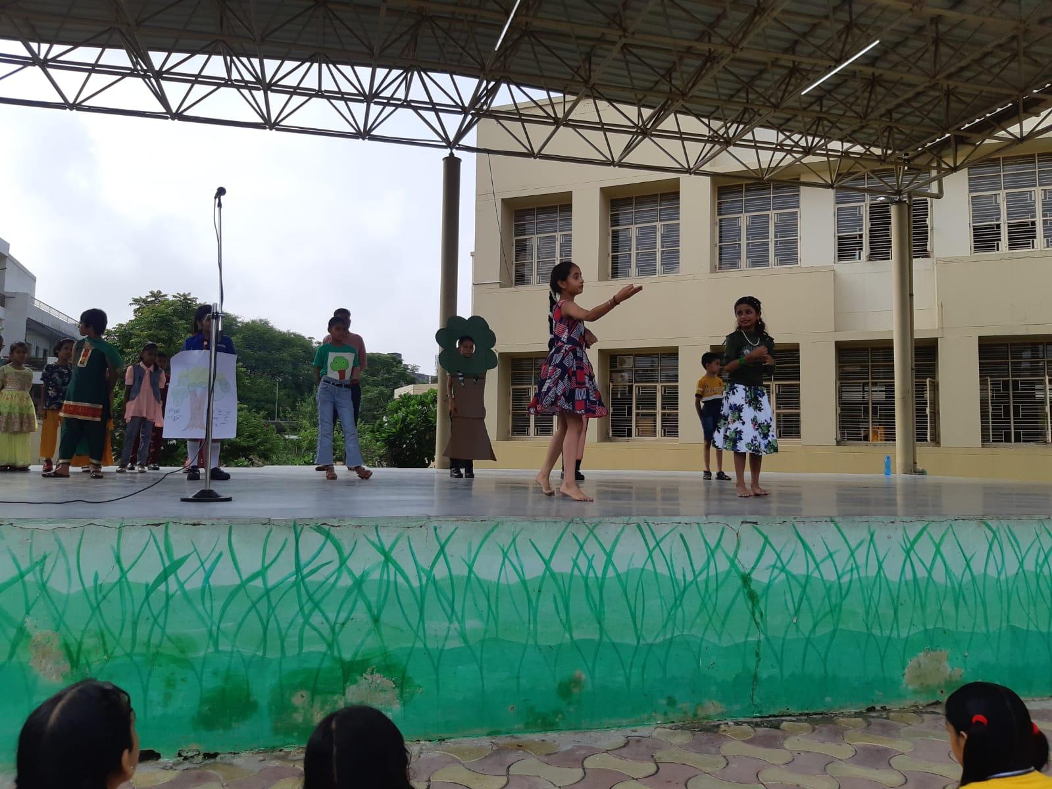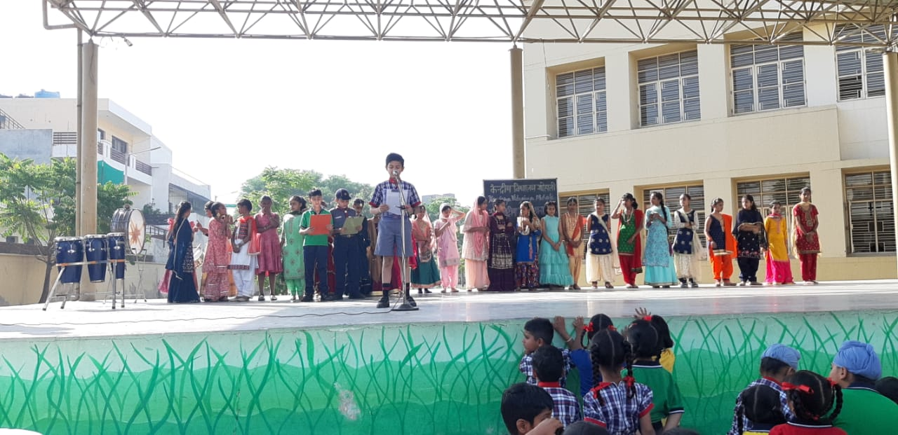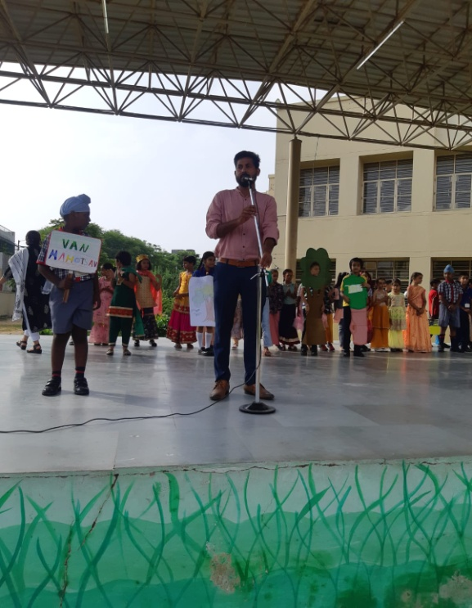
VAN MAHOTSAV
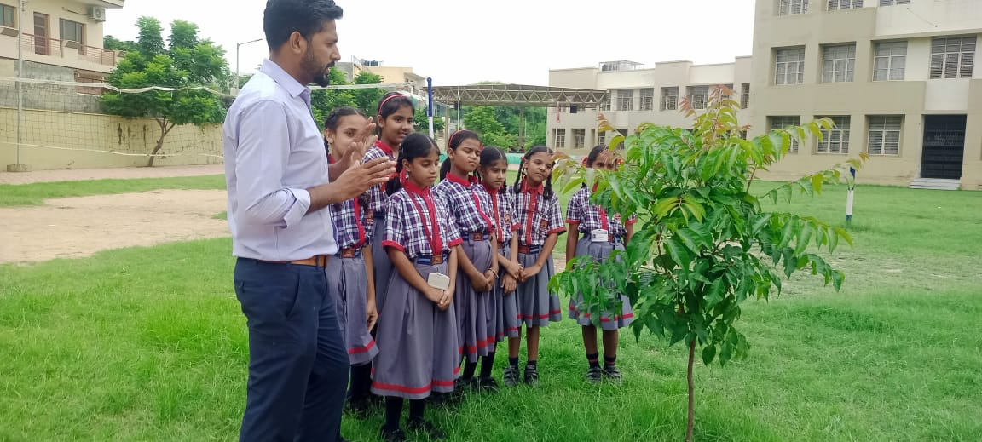
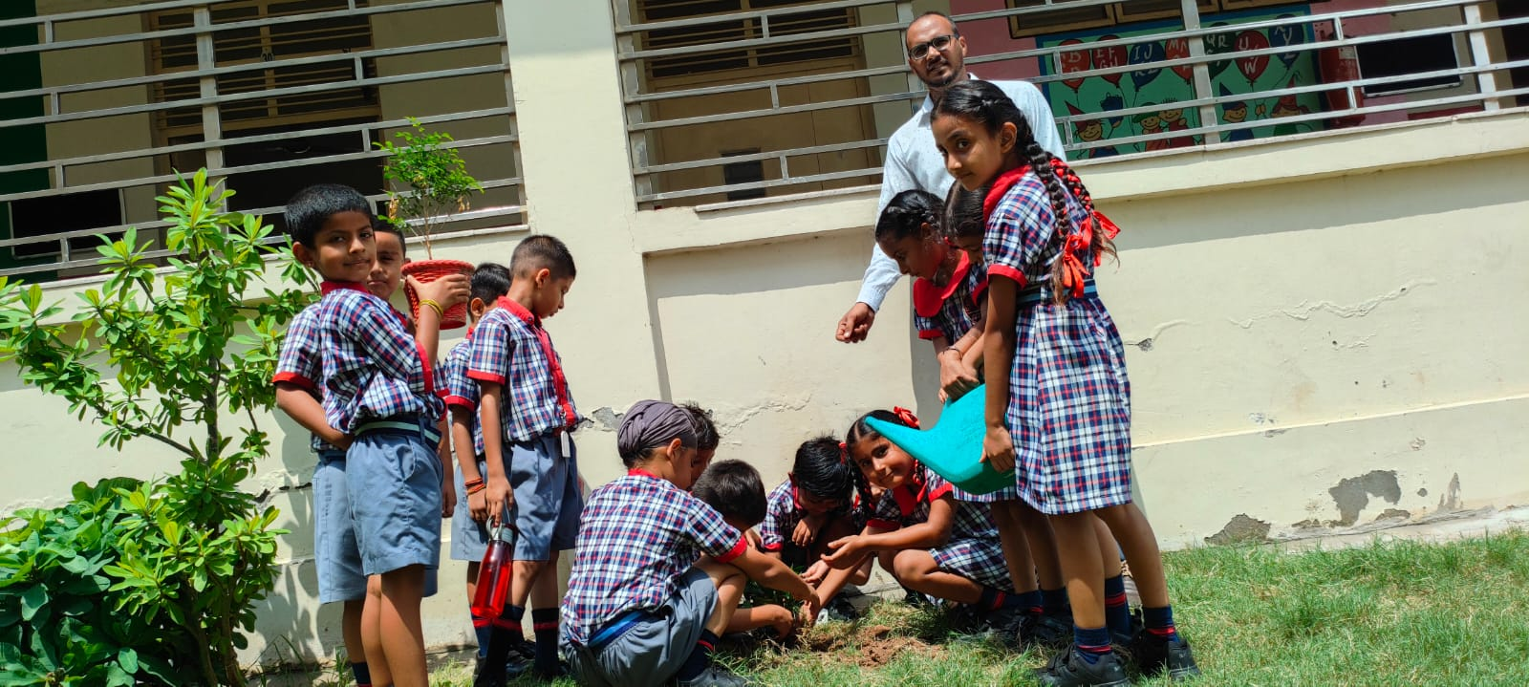
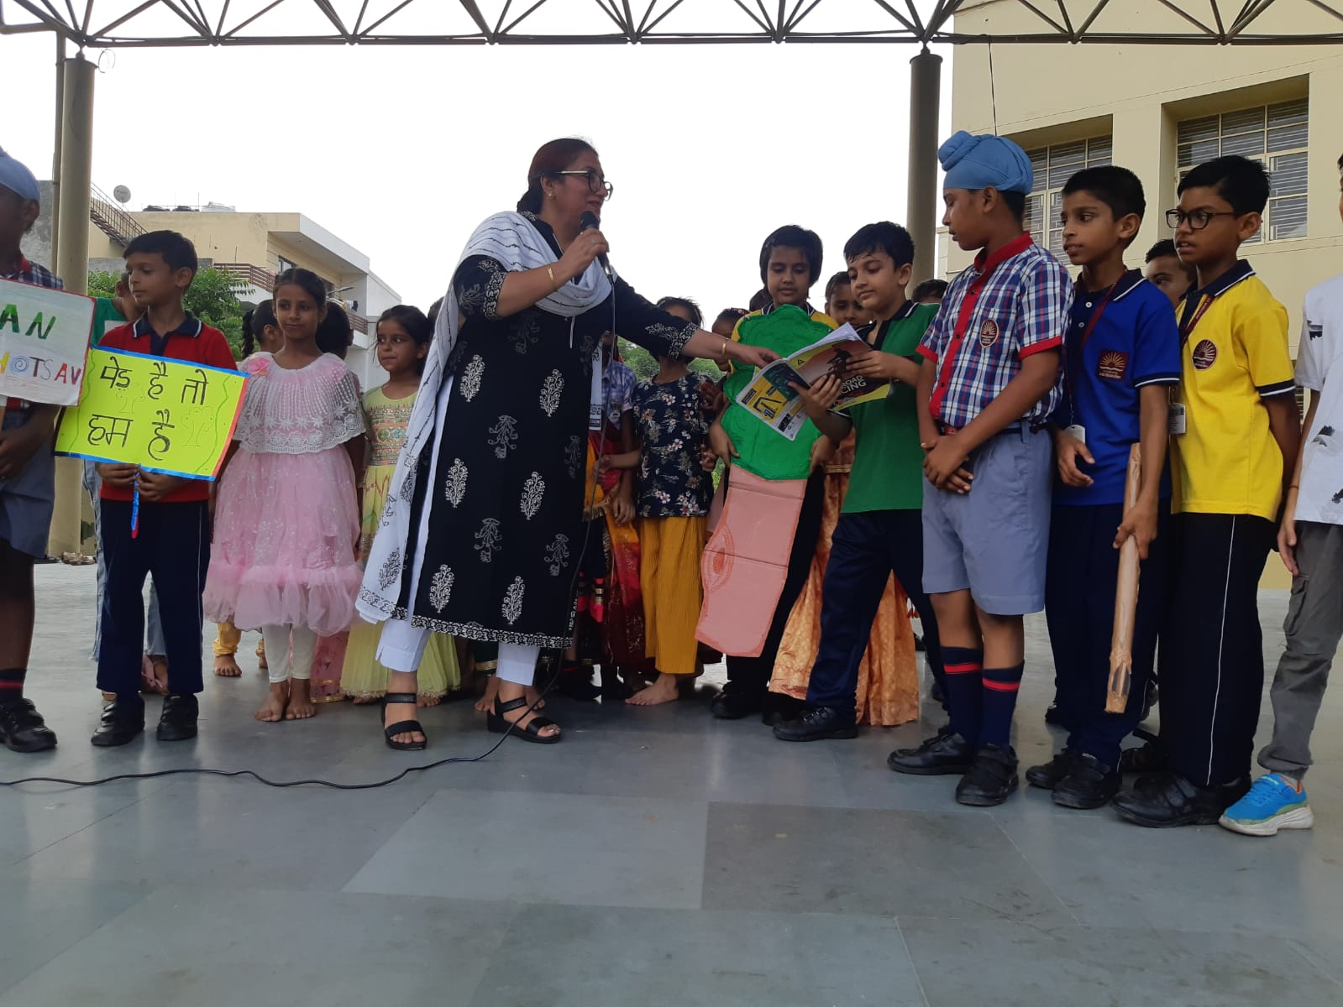
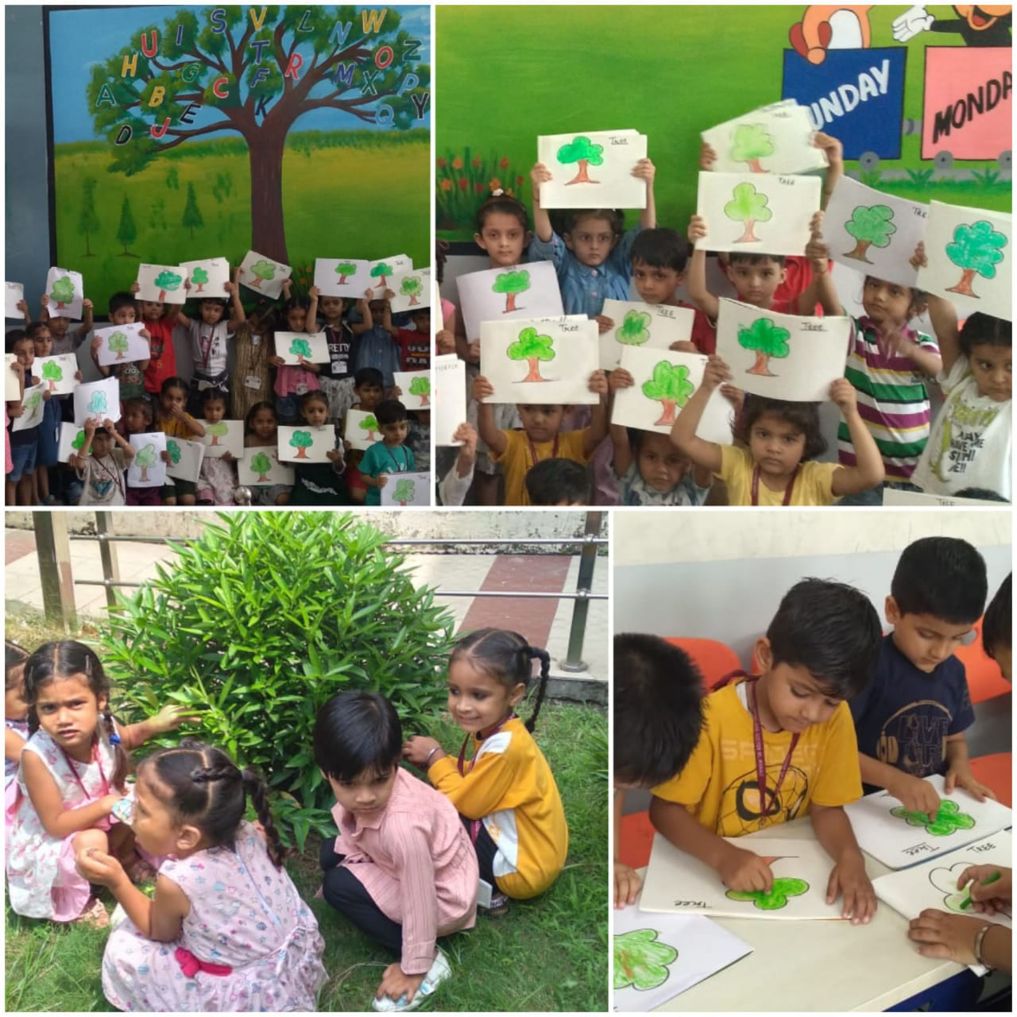
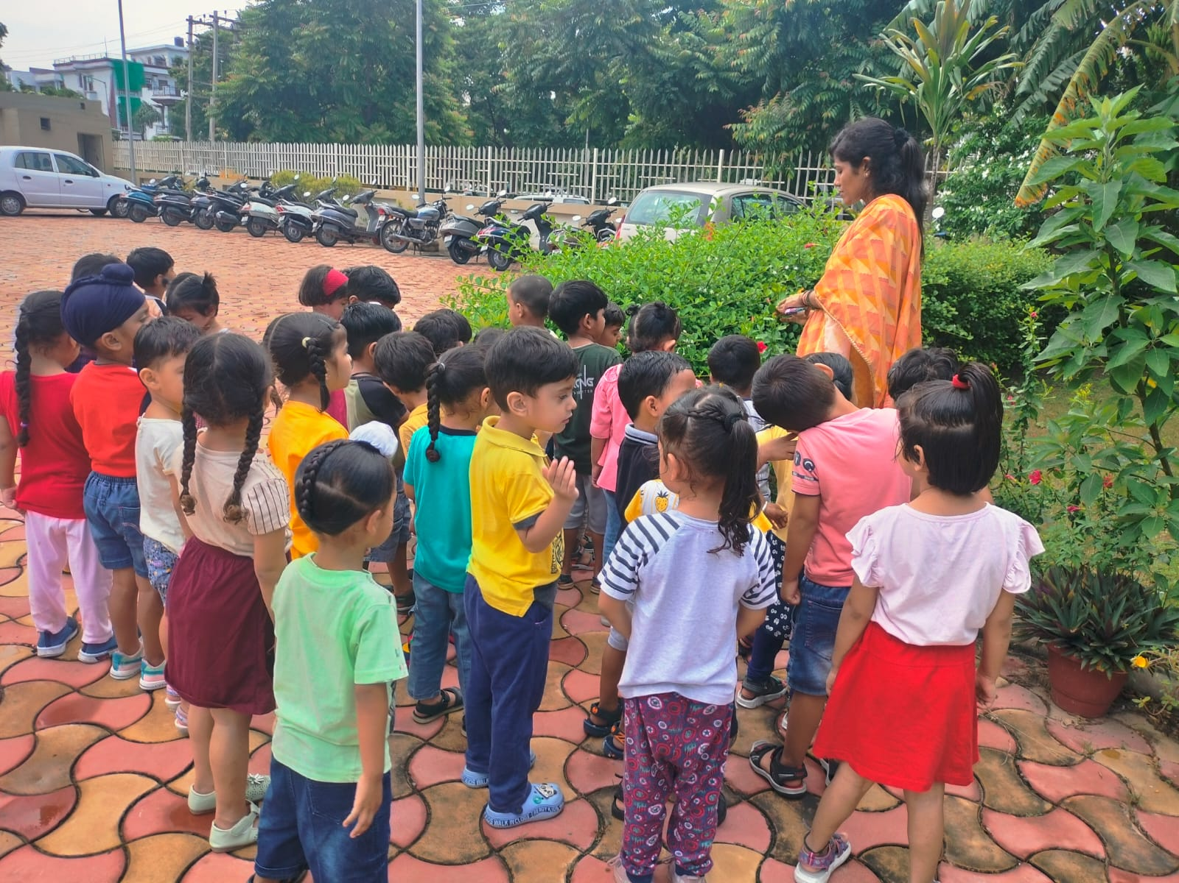
ACTIVITY BASED TEACHING
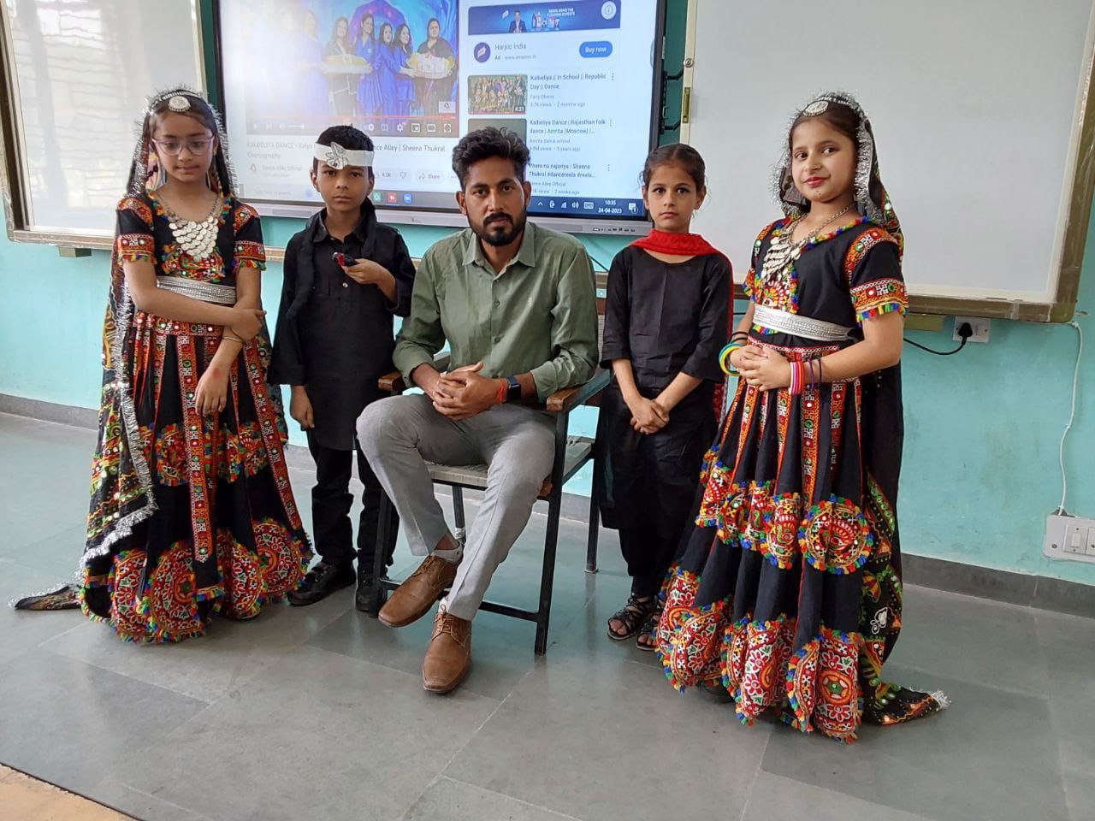
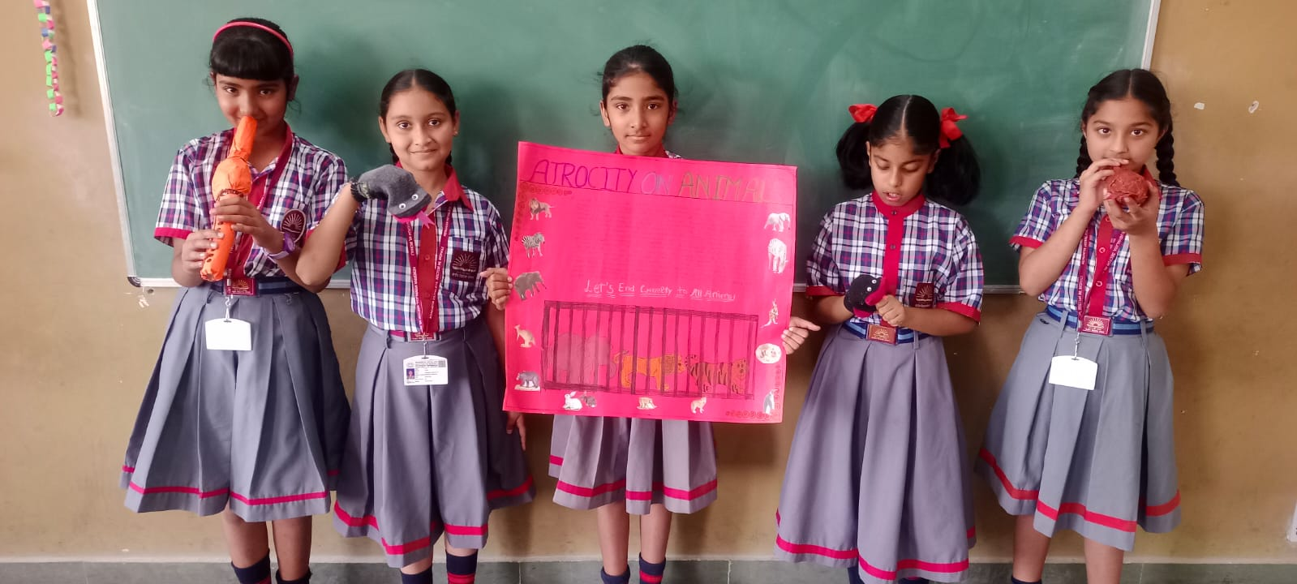
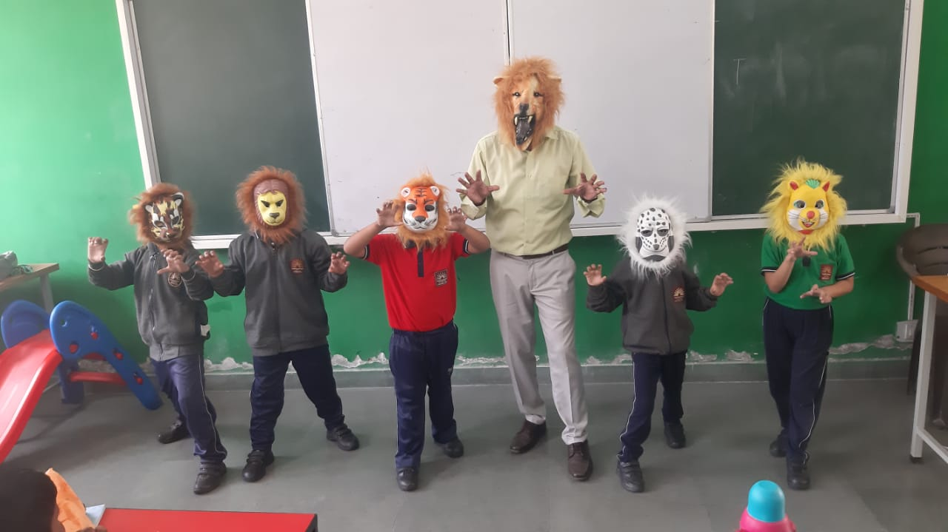
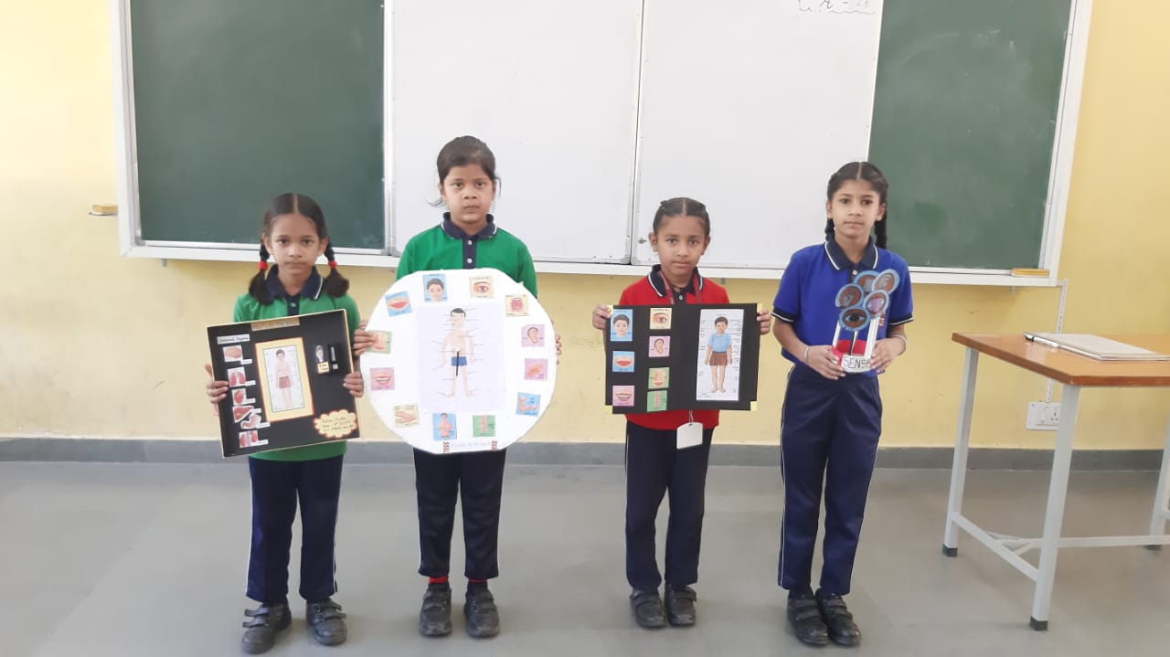
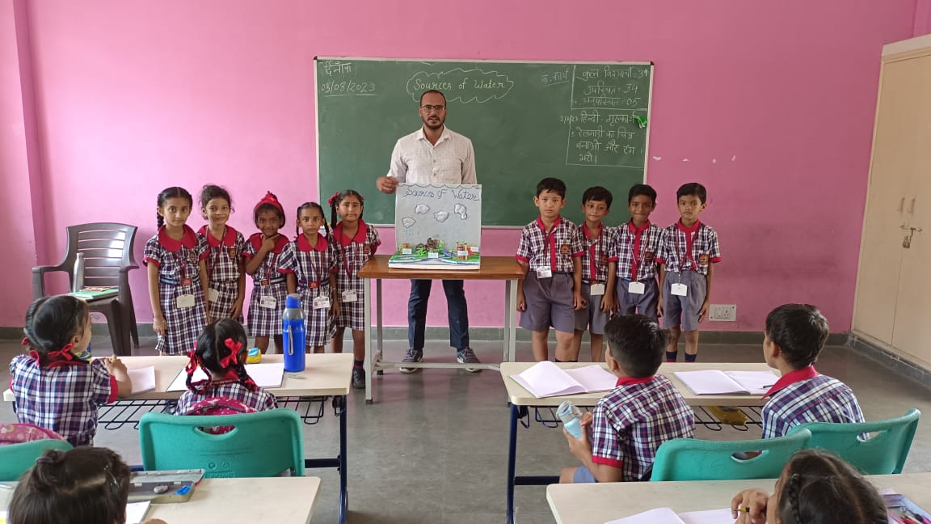
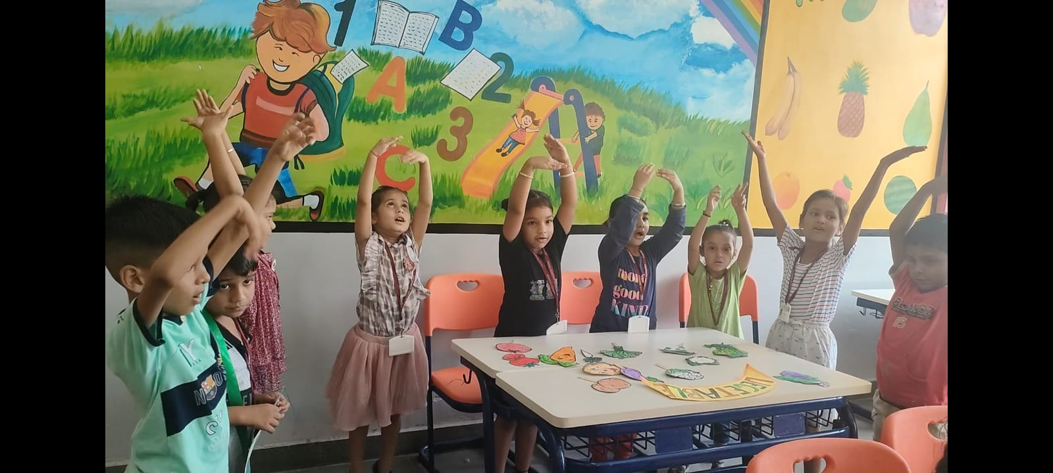
FUN DAY
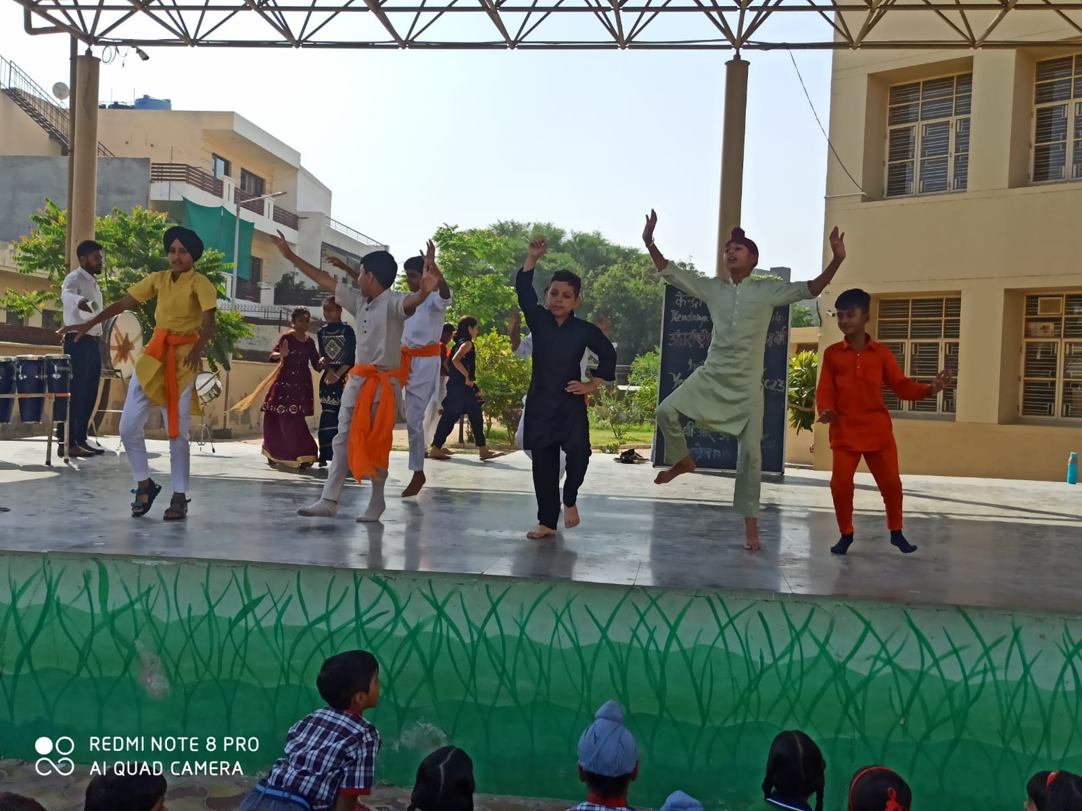
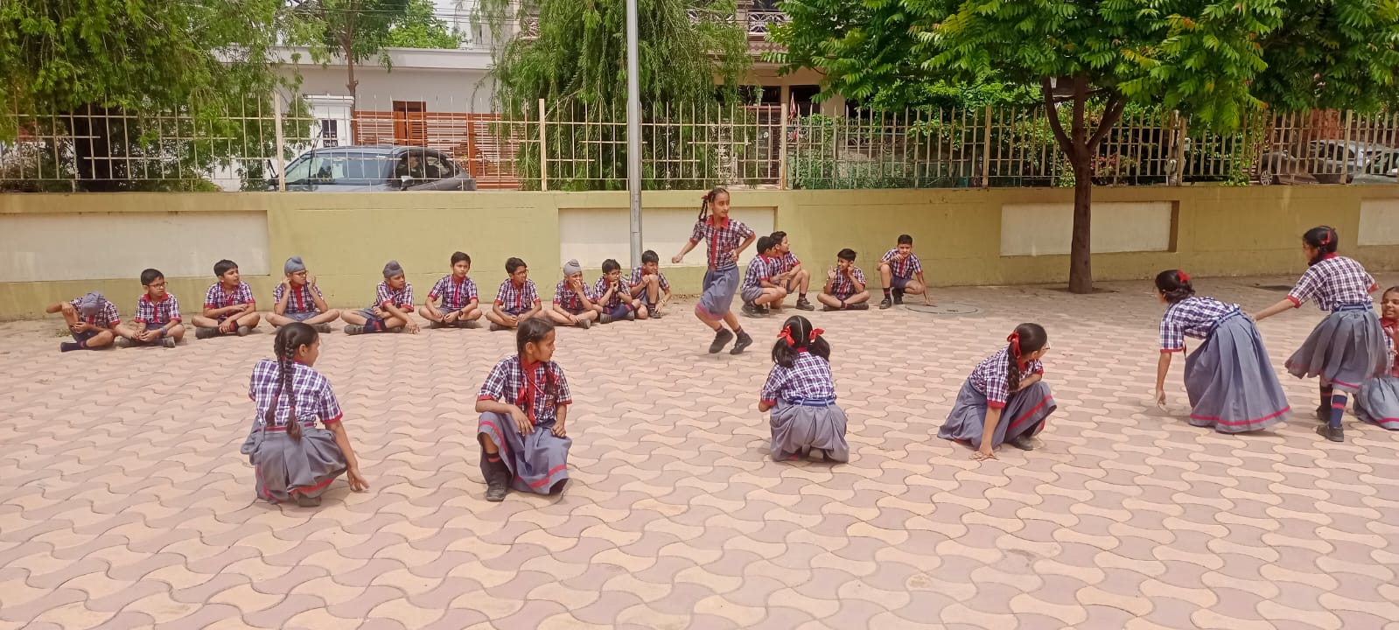
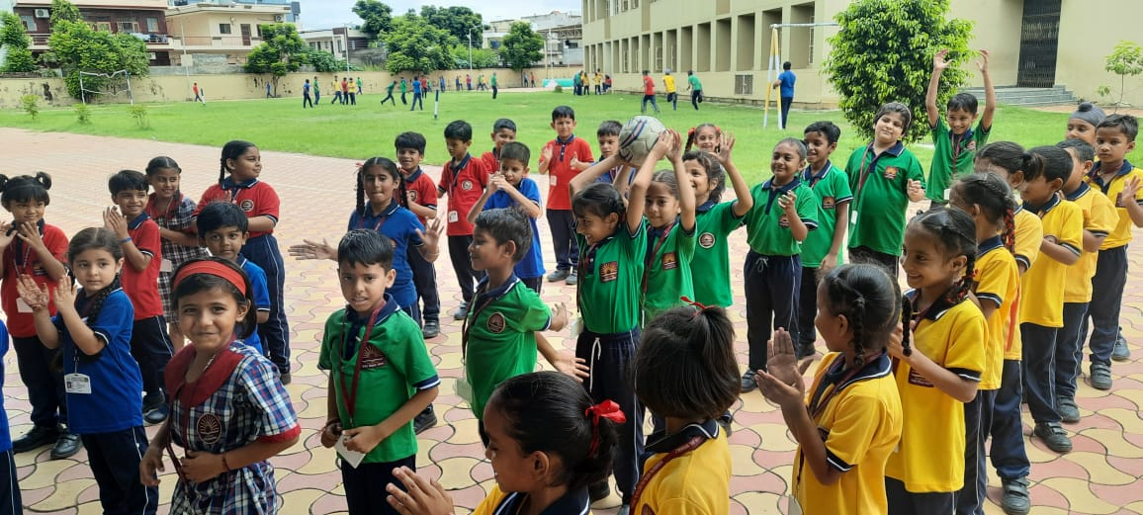
YOGA DAY
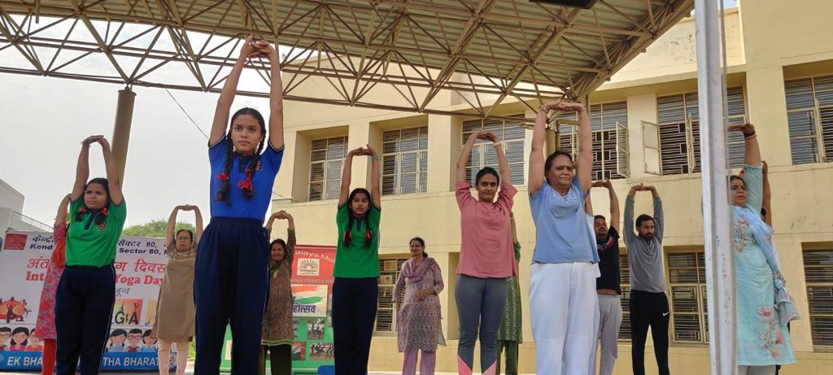
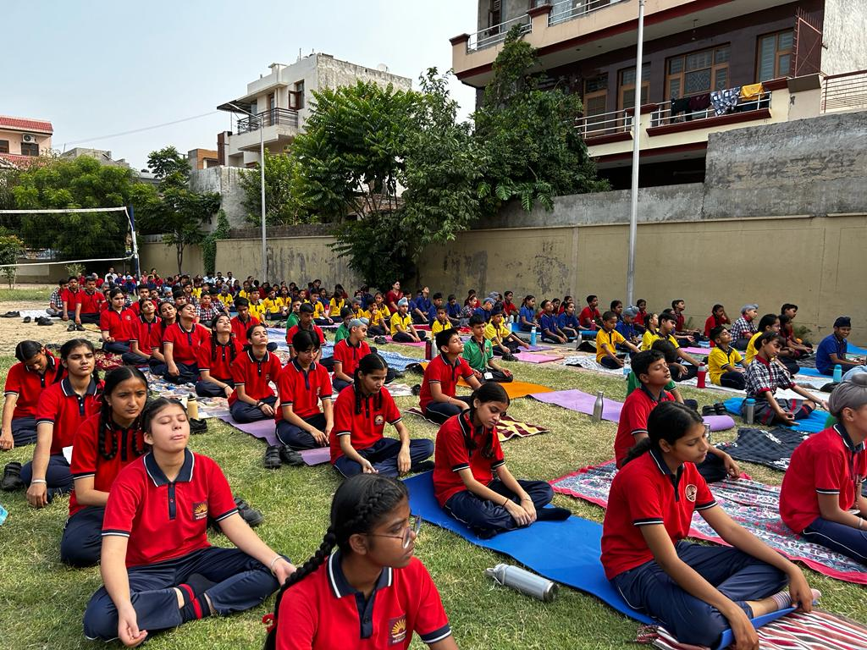
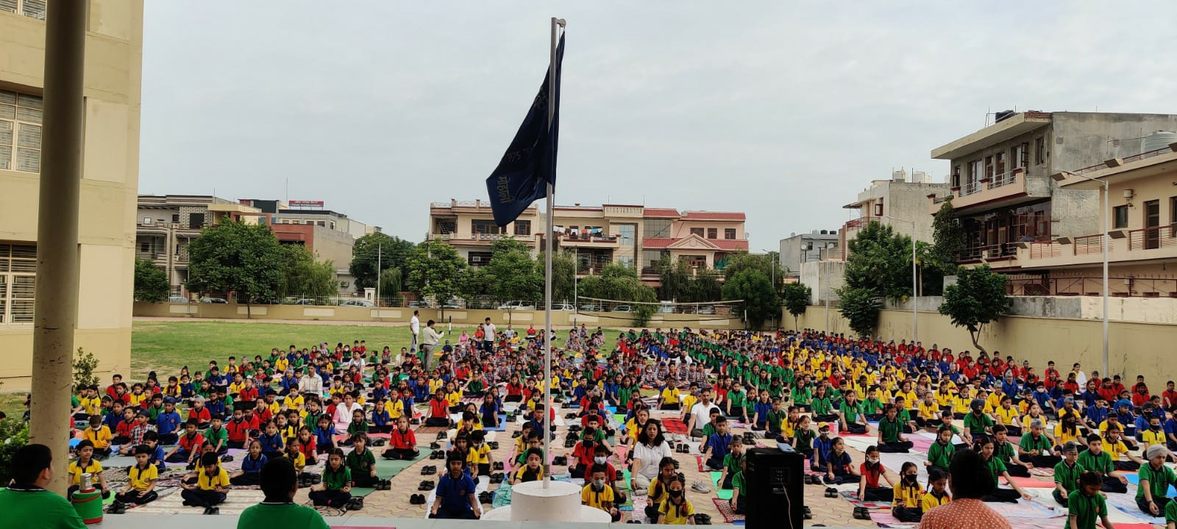
INVESTITURE CEREMONY
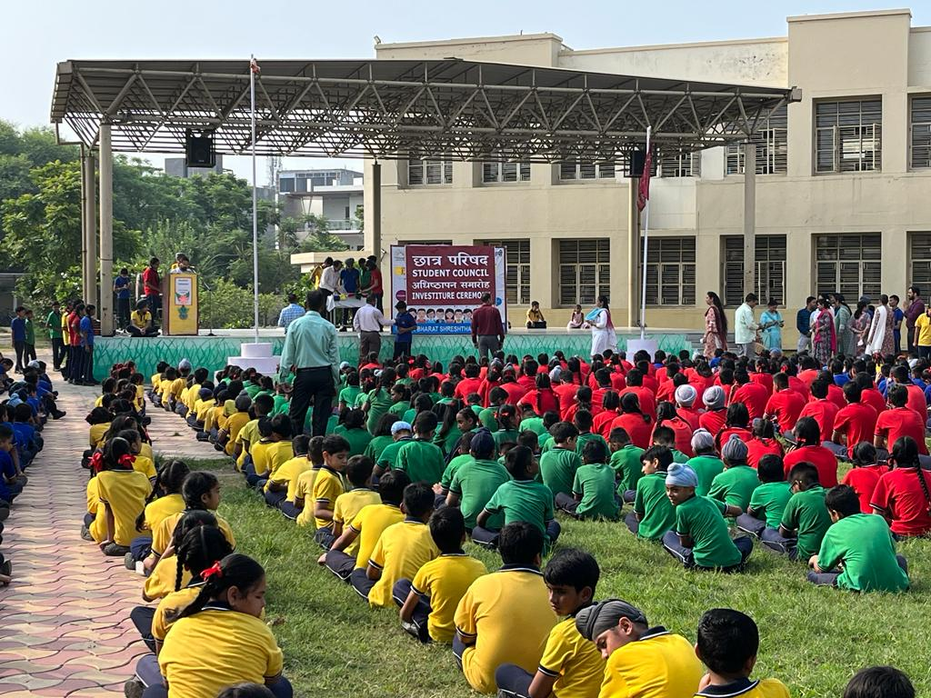
THANK YOU

